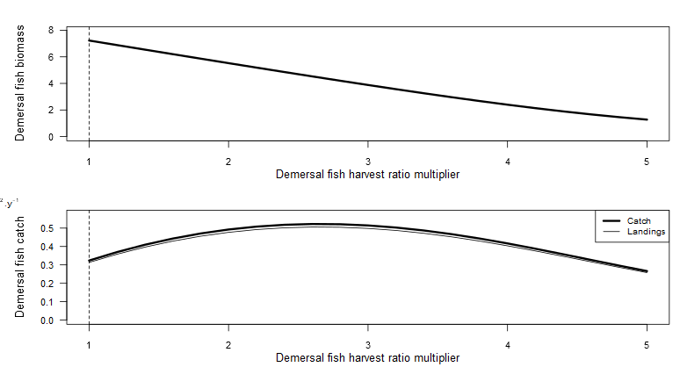

Supplementary Figure 1 Yield curves for Demersal fish harvesting. StrathE2EModels were ran using Demersal harvest ratio multipliers ranging from 1 to 5 in intervals of 0.2. Each harvest ratio is run to a steady state (50 years). The MSY is the point at which the curve peaks.

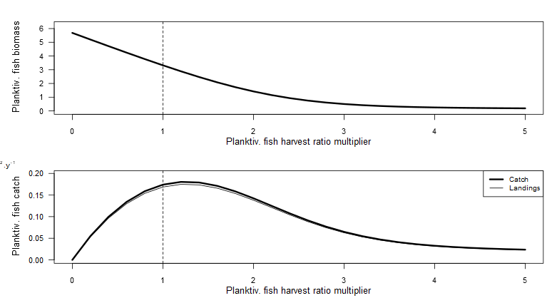

Supplementary Figure 2 Yield curves for Planktivorous fish harvesting. StrathE2EModels were ran using Demersal harvest ratio multipliers ranging from 1 to 5 in intervals of 0.2. Each harvest ratio is run to a steady state (50 years). The MSY is the point at which the curve peaks.

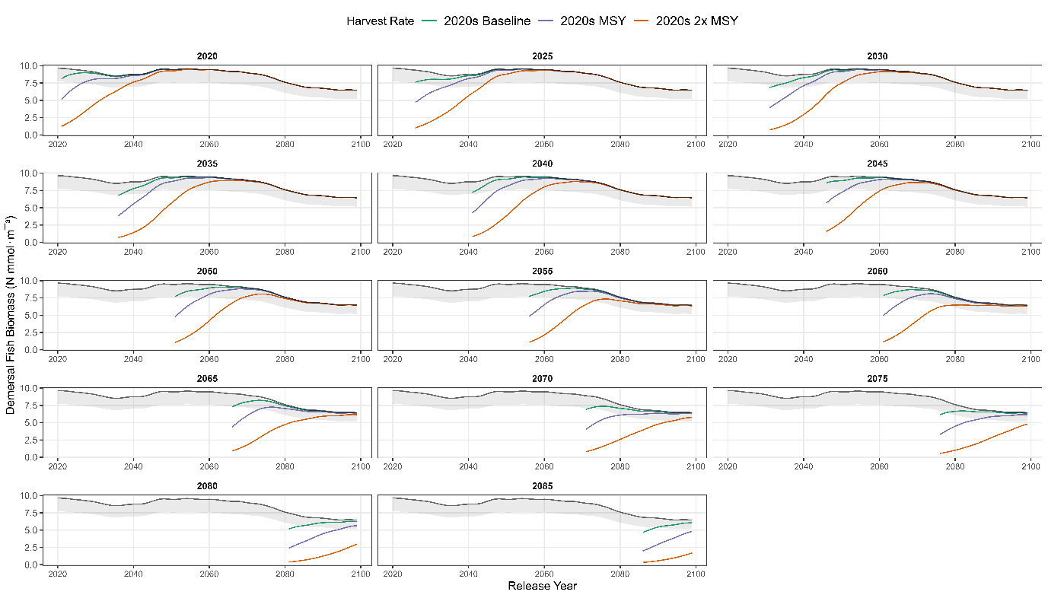

Supplementary Figure 3 Recovery trajectories for each release year for Demersal fish.

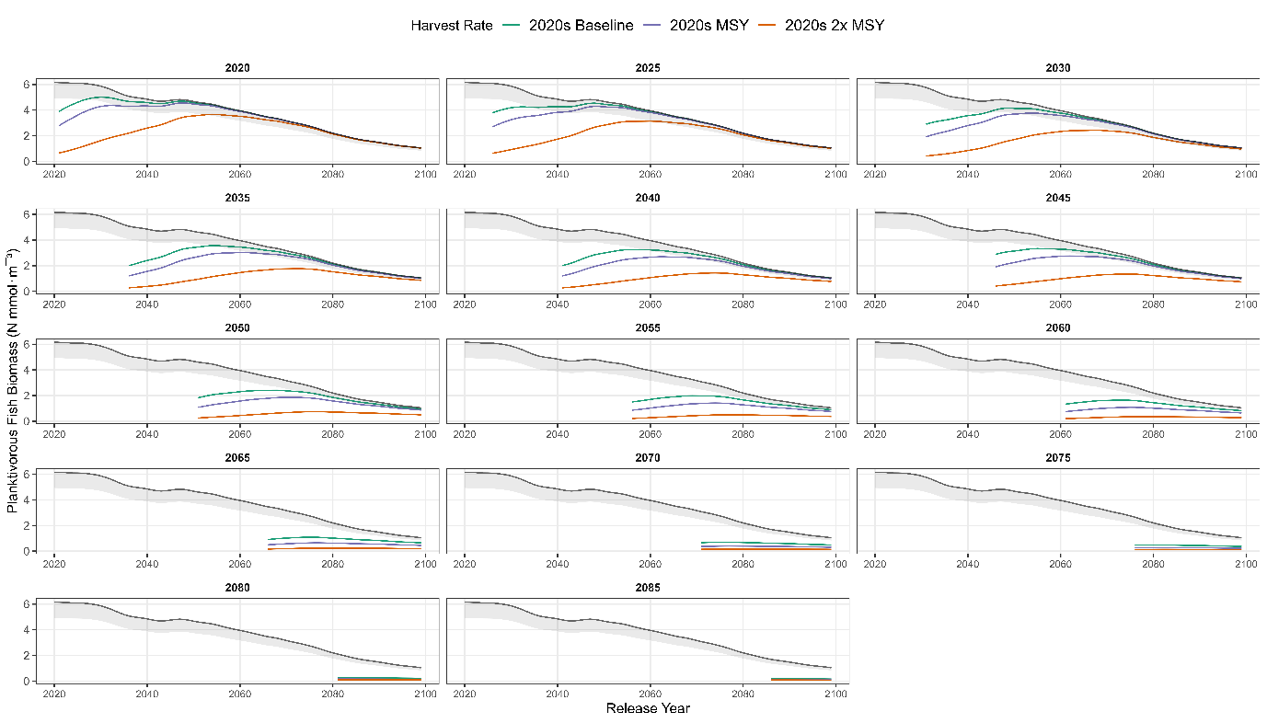

Supplementary Figure 4 Recovery trajectories for each release year for Planktivorous fish.

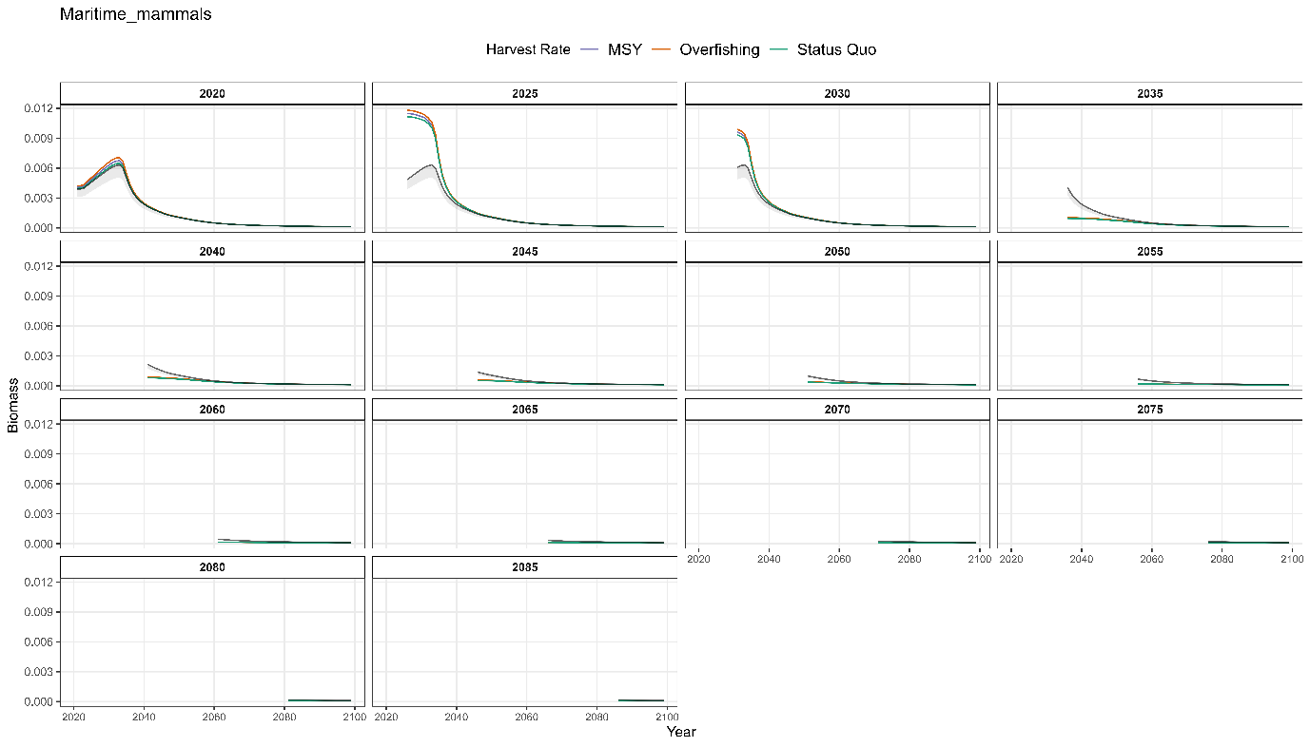

Supplementary Figure 5 Maritime Mammal Recovery trajectories per release year under Demersal fishing.

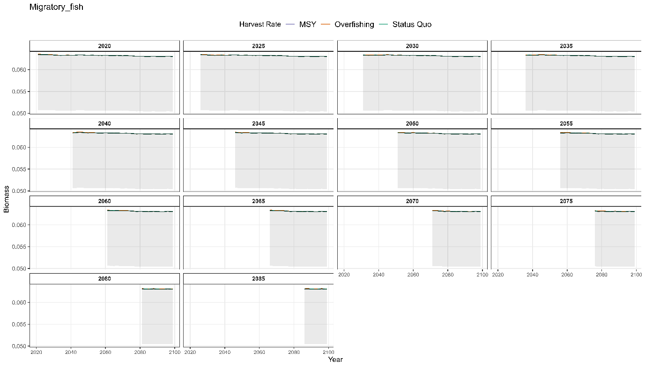

Supplementary Figure 6 Migratory Fish Recovery trajectories per release year under Demersal fishing.

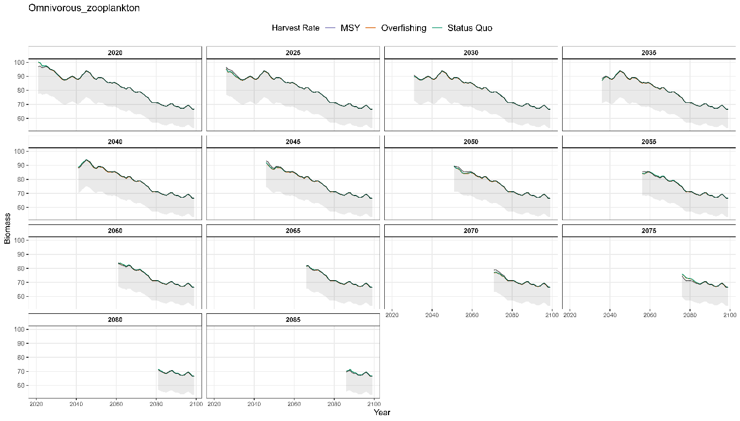

Supplementary Figure 7 Omnivorous Zooplankton Recovery trajectories per release year under Demersal fishing.

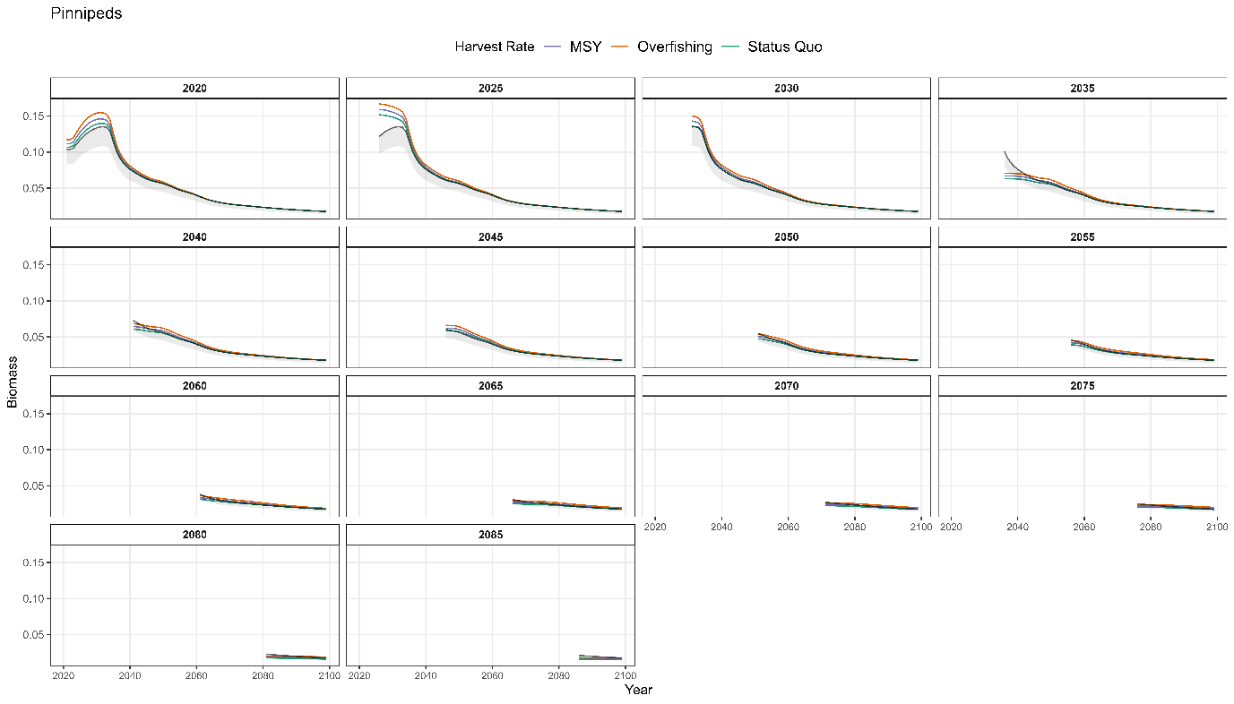

Supplementary Figure 8 Pinnipeds Recovery trajectories per release year under Demersal fishing.

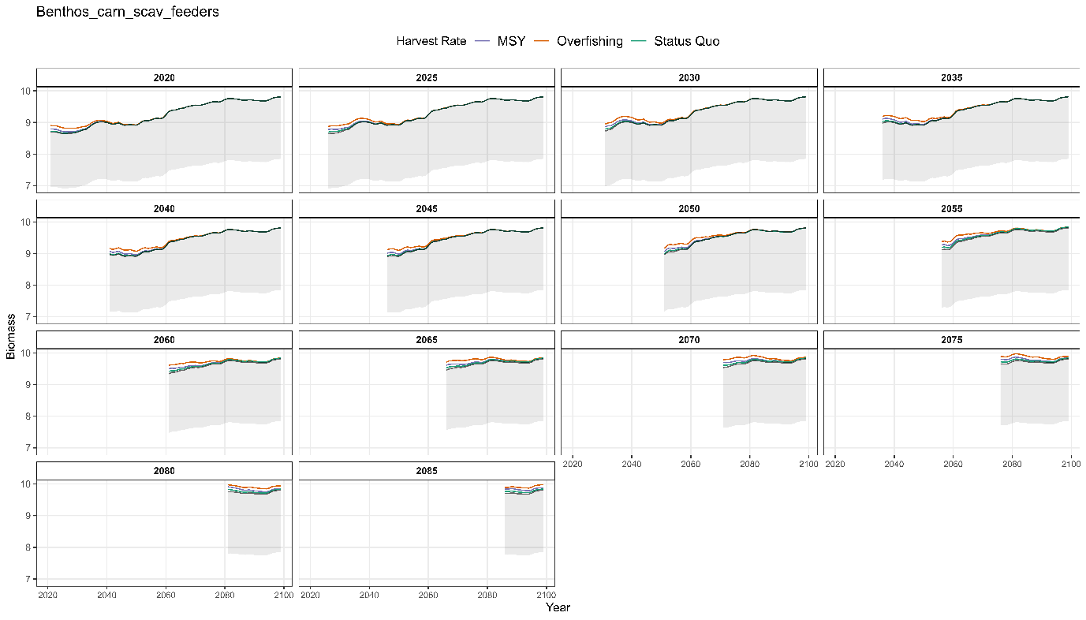

Supplementary Figure 9 Carnivorous Scavenging Benthos Recovery trajectories per release year under Demersal fishing.

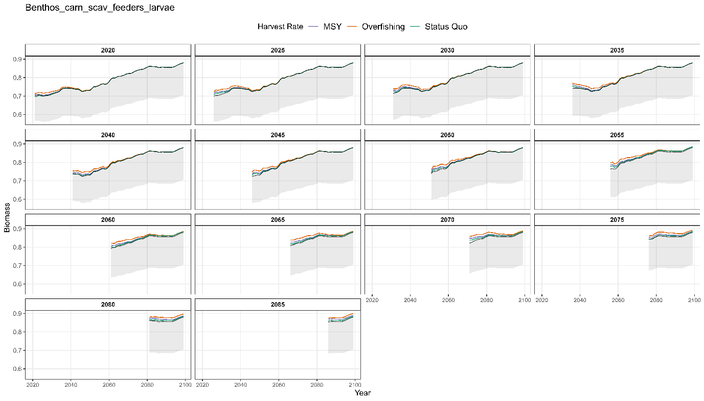

Supplementary Figure 10 Carnivorous Scavenging Benthos Larvae Recovery trajectories per release year under Demersal fishing.

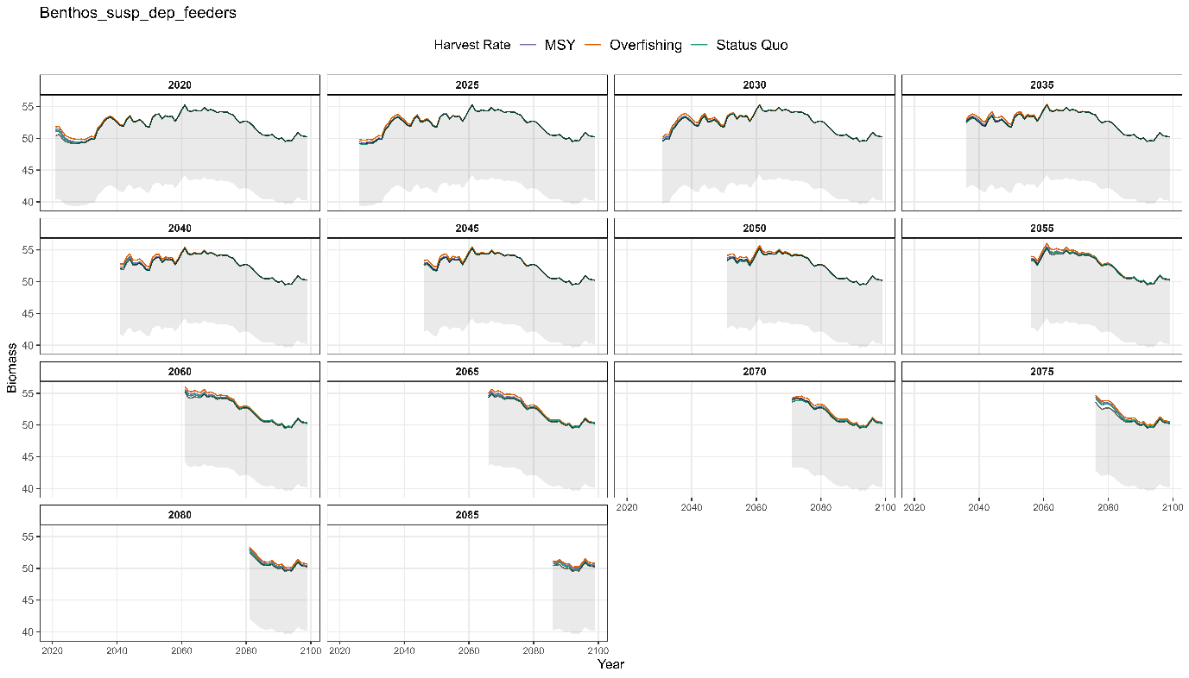

Supplementary Figure 11 Suspension and Deposit feeding Benthos Recovery trajectories per release year under Demersal fishing.

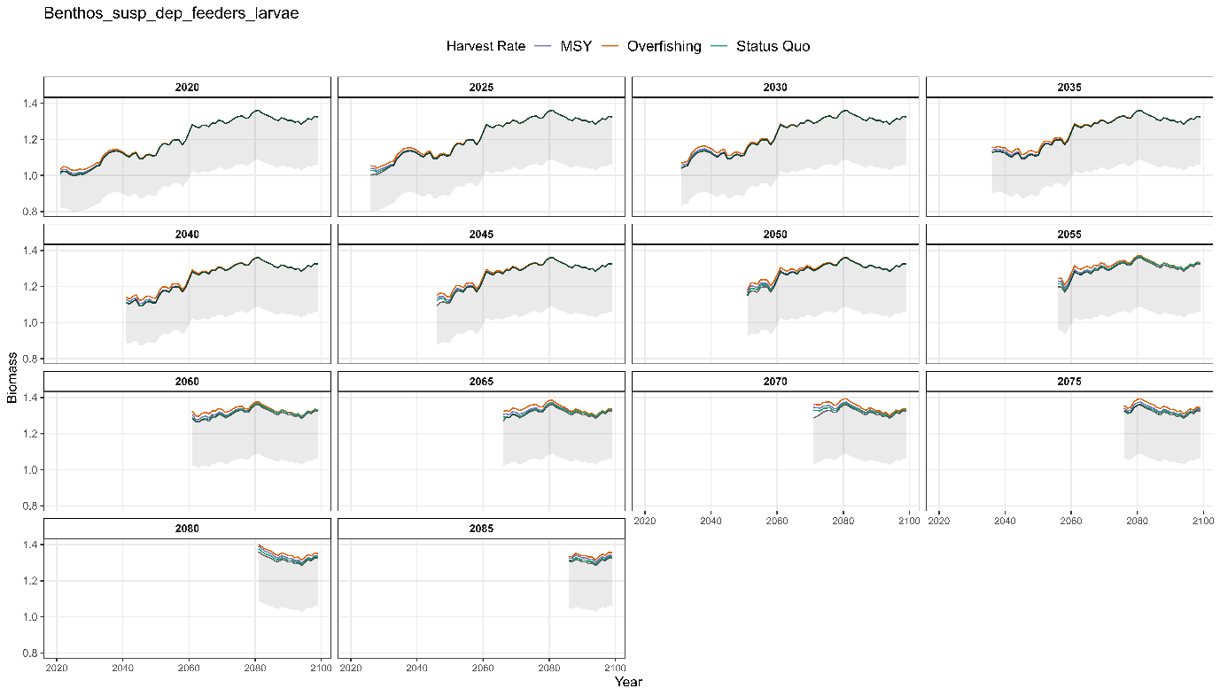

Supplementary Figure 12 Suspension and Deposit feeding Benthos Larvae Recovery trajectories per release year under Demersal fishing.

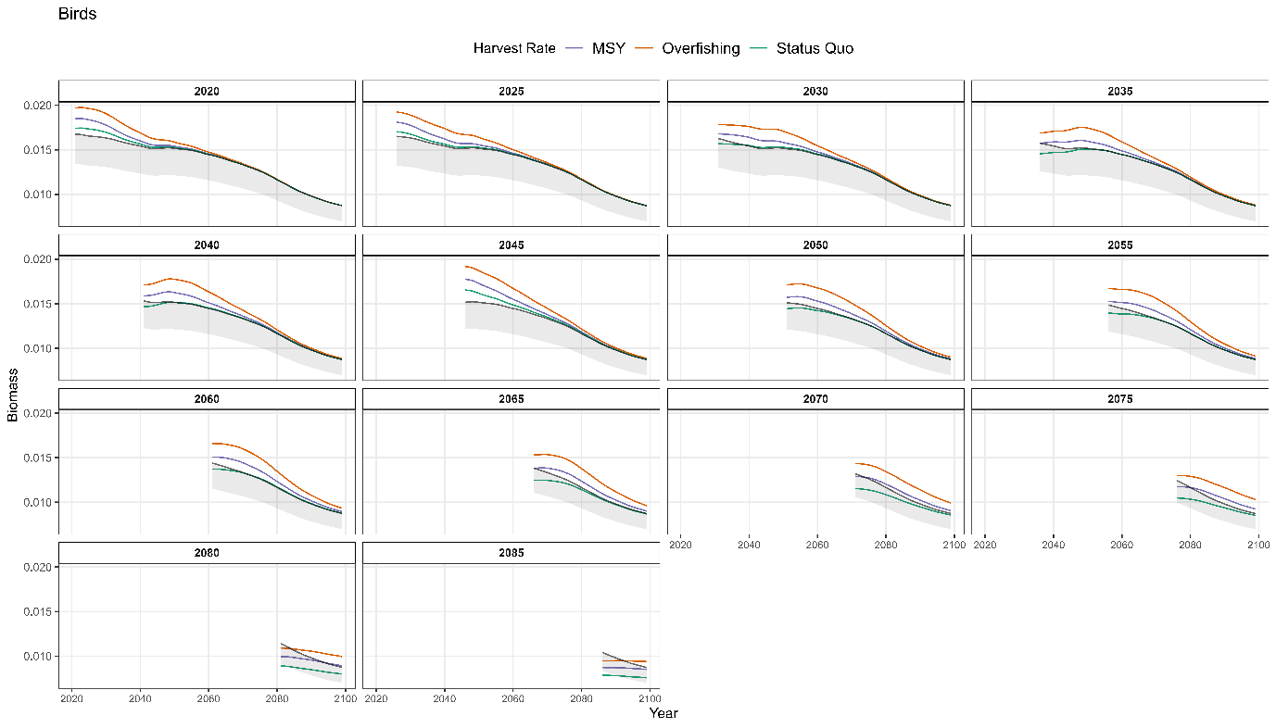

Supplementary Figure 13 Birds Recovery trajectories per release year under Demersal fishing.

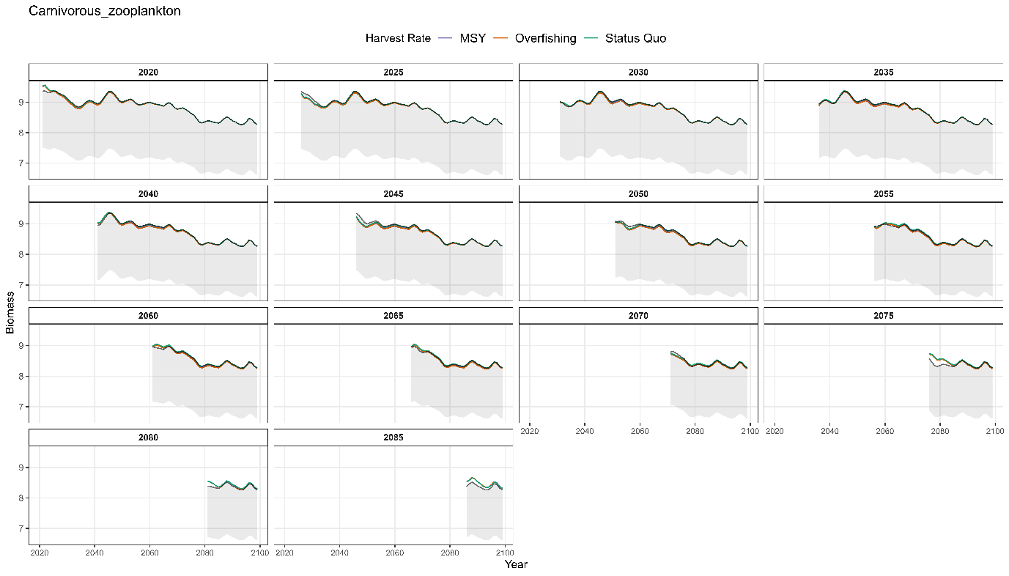

Supplementary Figure 14 Carnivorous Zooplankton Recovery trajectories per release year under Demersal fishing.

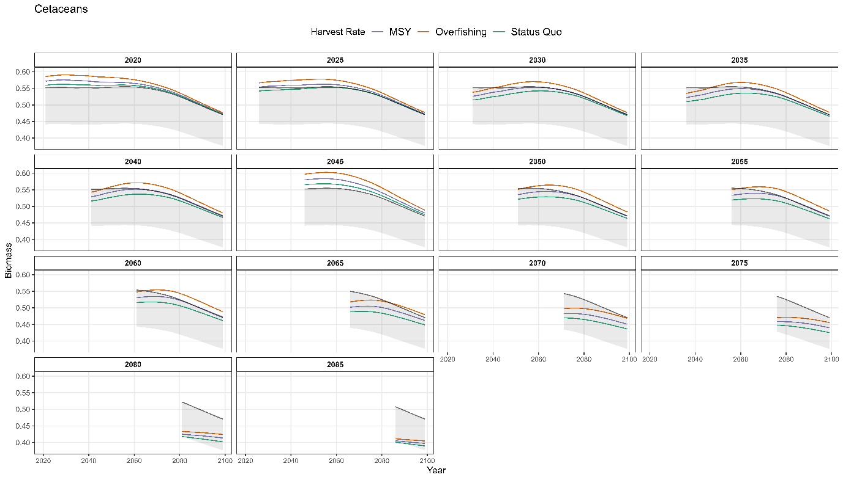

Supplementary Figure 15 Cetaceans Recovery trajectories per release year under Demersal fishing.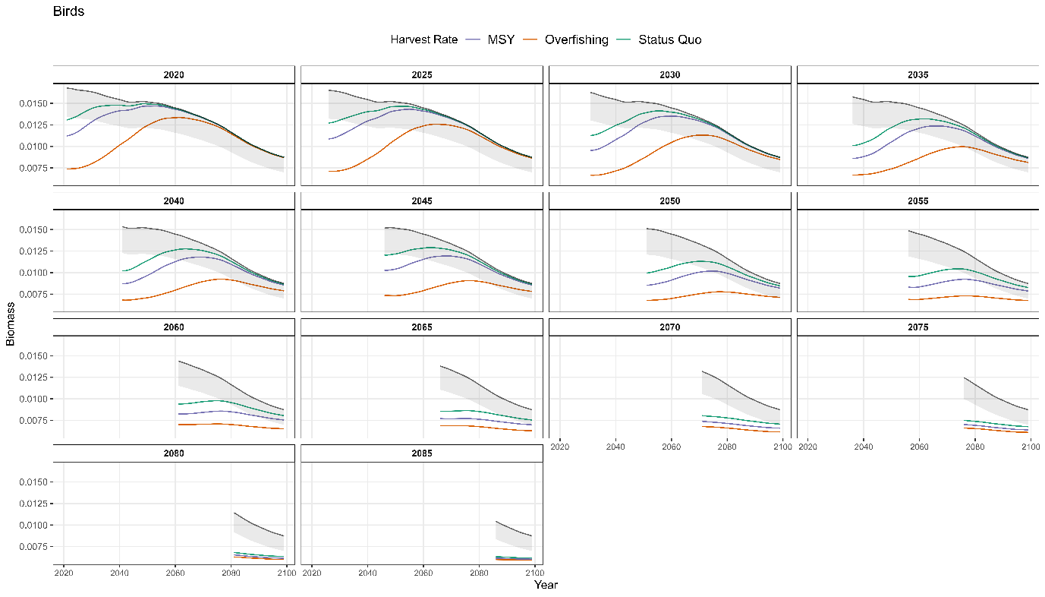

Supplementary Figure 16 Birds Recovery trajectories per release year under Planktivorous fishing.

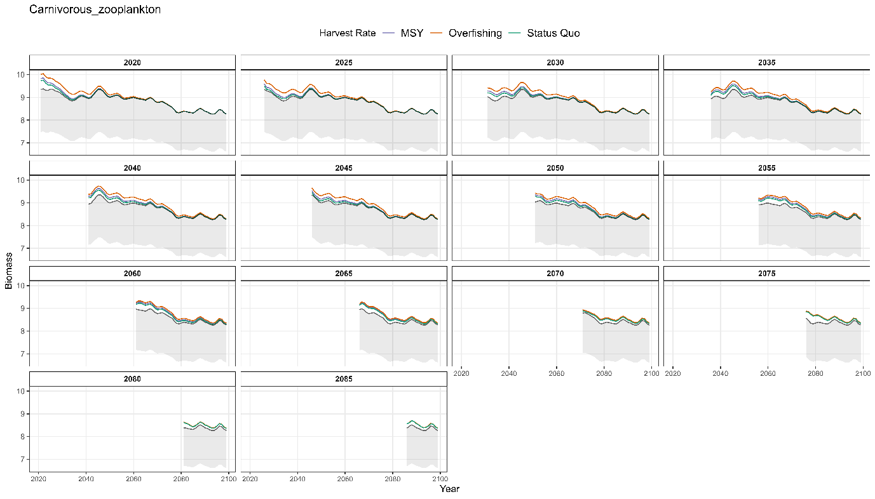

Supplementary Figure 17 Carnivorous zooplankton Recovery trajectories per release year under Planktivorous fishing.

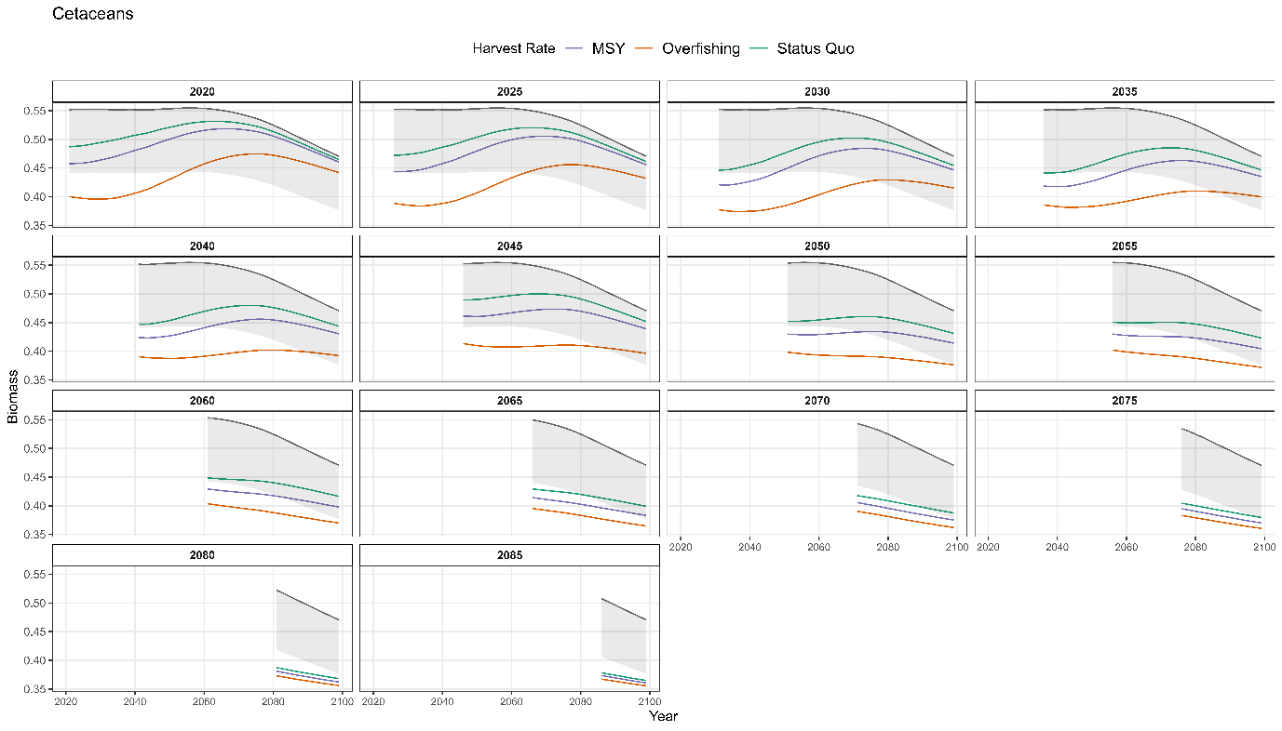

Supplementary Figure 18 Cetacean Recovery trajectories per release year under Planktivorous fishing.

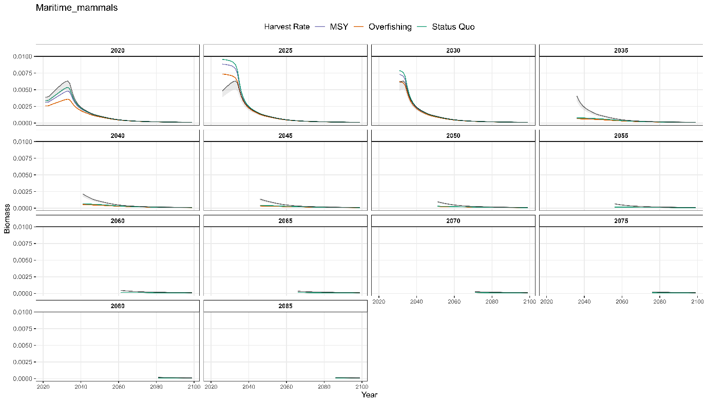

Supplementary Figure 21 Maritime Mammal Recovery trajectories per release year under Planktivorous fishing.

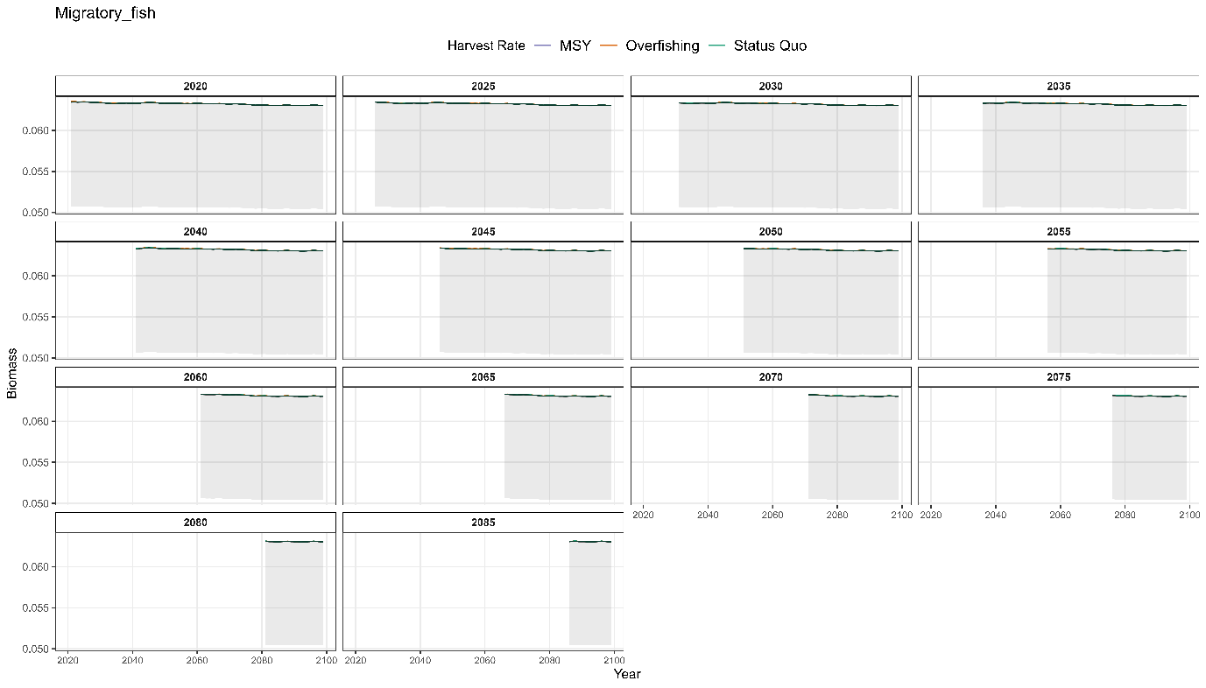

Supplementary Figure 22 Migratory fish Recovery trajectories per release year under Planktivorous fishing.

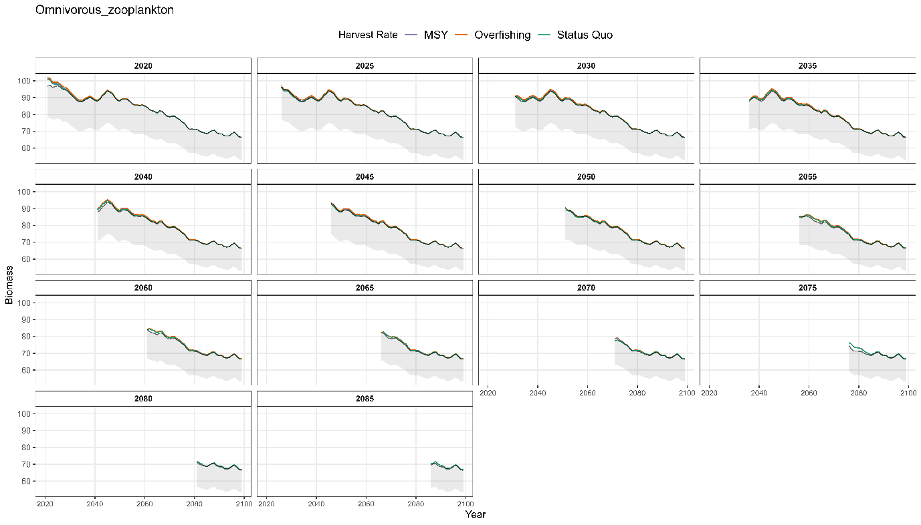

Supplementary Figure 23 Omnivorous Zooplankton Recovery trajectories per release year under Planktivorous fishing.

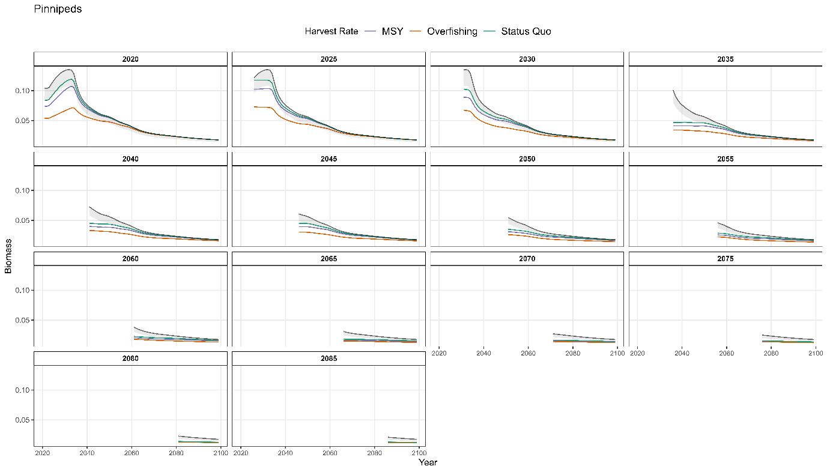

Supplementary Figure 24 Pinniped Recovery trajectories per release year under Planktivorous fishing.

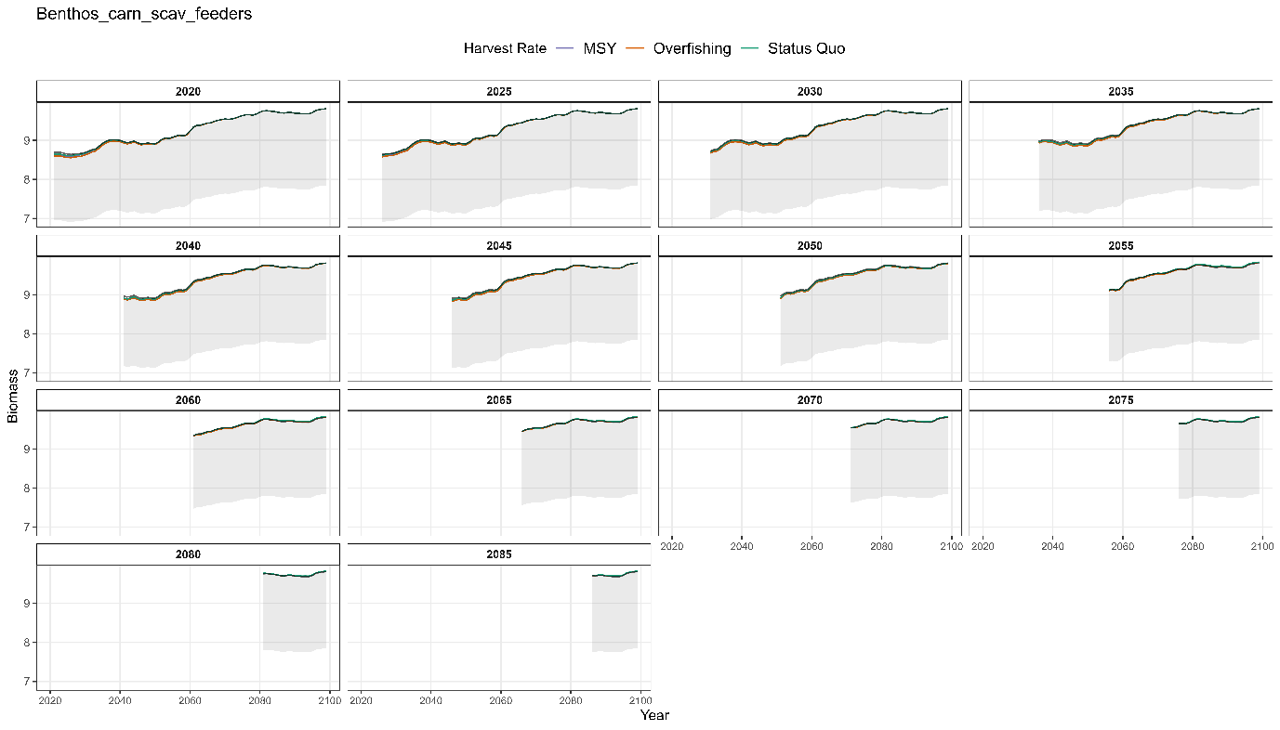

Supplementary Figure 25 Carnivorous Scavenging Benthos Recovery trajectories per release year under Planktivorous fishing.

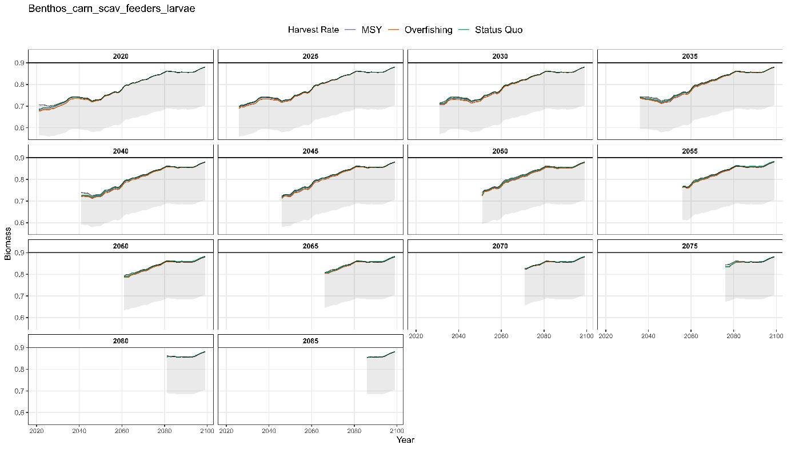

Supplementary Figure 26 Carnivorous Scavenging Benthos Larvae Recovery trajectories per release year under Planktivorous fishing.

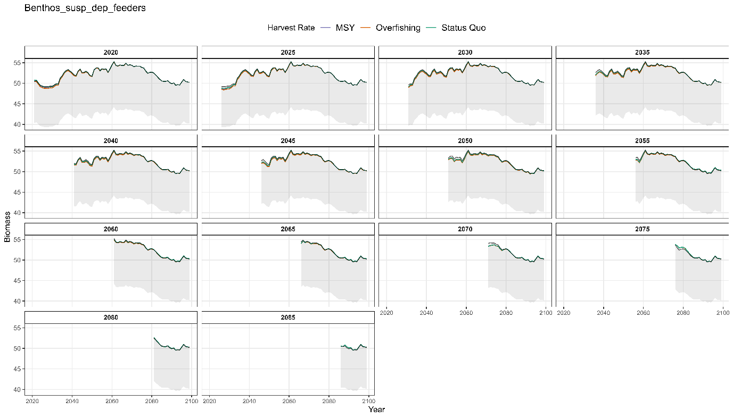

Supplementary Figure 27 Suspension and Deposit feeding Benthos Recovery trajectories per release year under Planktivorous fishing.

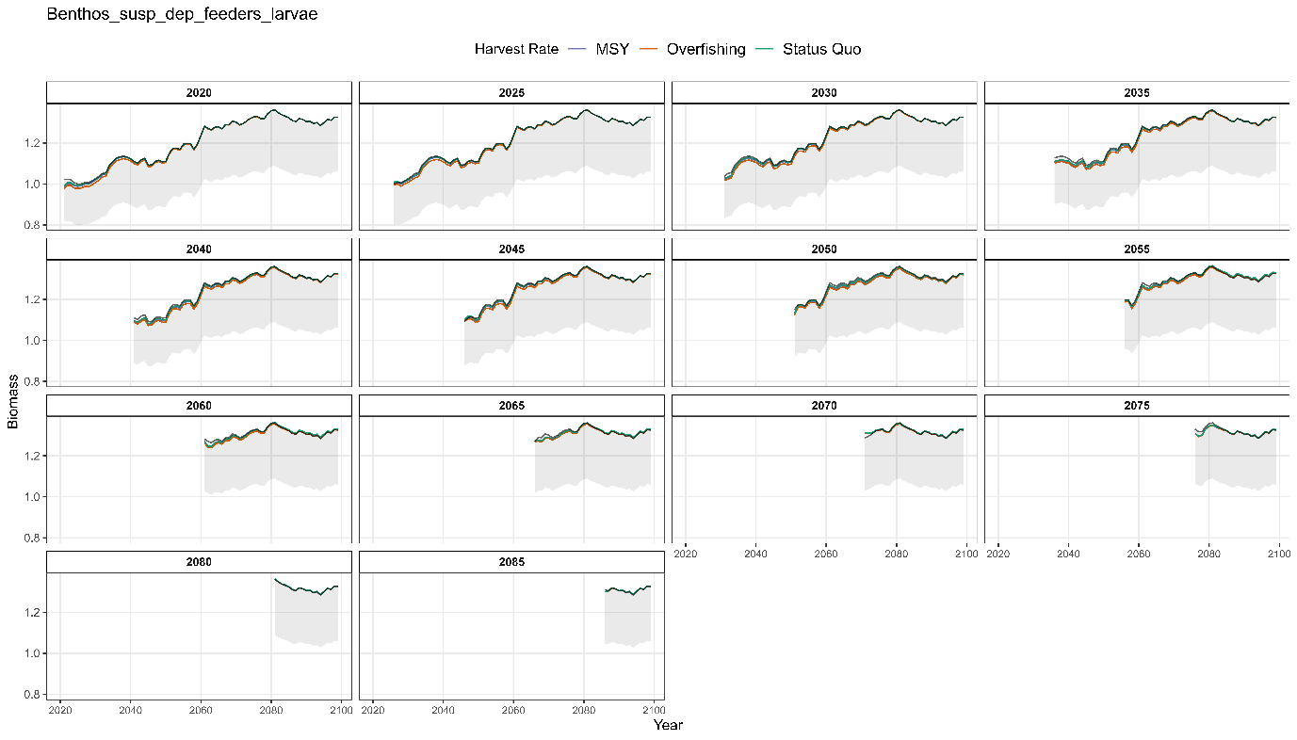

Supplementary Figure 28 Suspension and Deposit feeding Benthos Larvae Recovery trajectories per release year under Planktivorous fishing.